Sunday, 20 September 2026, postcard

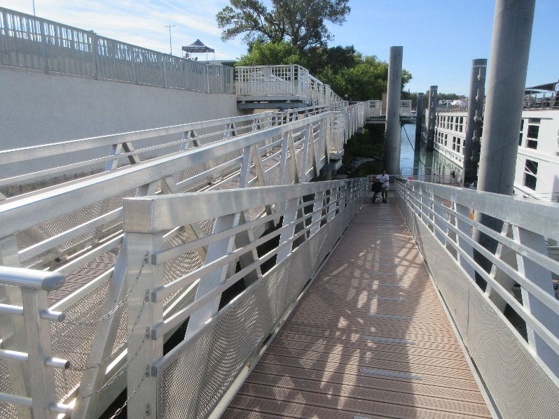
On Sunday, we were in Arles, our last stop before disembarkation. In the morning, I chose the walking tour of Arles (over biking in the Arles countryside), and David chose to stay aboard the ship. As it turned out, just getting off the ship was a challenge. We were moored outboard of another ship, from a different company, and just to get to street level, we had to climb three short flights to our sundeck, cross over onto their sundeck, climb down three short flights, go into the other ship and down one flight of stairs inside before exiting to the gangplank, walk down it, cross a cement area, climb a looong ramp (with two switchbacks, shown here), cross another cement area and choose between another ramp and a flight of stairs to reach the street. Whew!
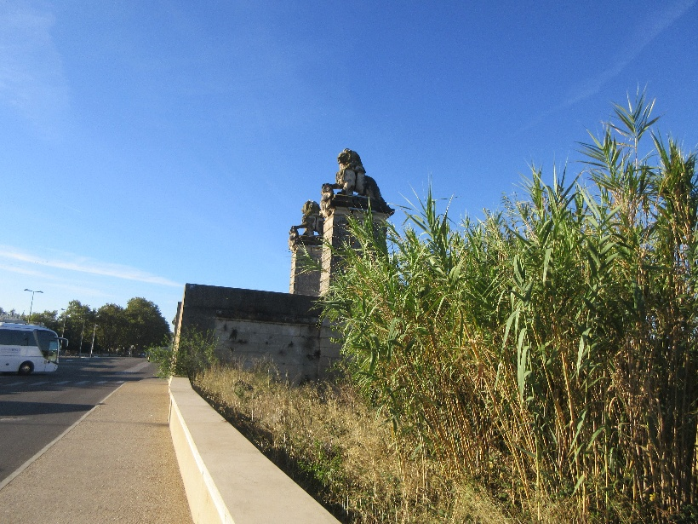
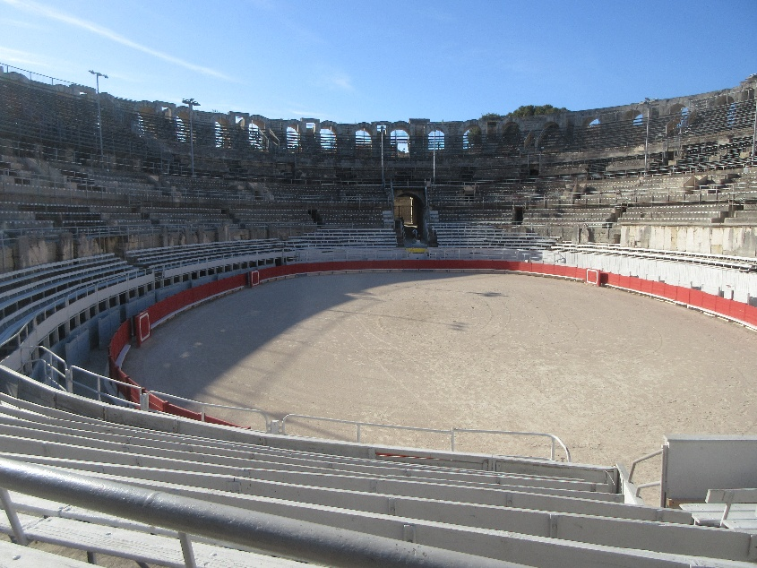
I joined the "gentle walkers" group, which turned out to be just me and one other passenger, and the other gentle walker proved so slow (she walked with a cane and had increasing difficulty as the days went on, but she was a trouper) that we visited only a few of the sites on the normal itinerary. That was okay with me, as we've toured Arles before. The first sight was this pair of stone (or perhaps concrete) lions. They date not from Roman times but from 1866, when they were erected to mark the near end of a railway bridge over the river. The bridge (and much of the town itself) was bombed in 1944 by the allies (to impede enemy troop movements) and all that remain of it are these two lions, a matching pair on the far bank, and two sets of supporting columns out in the river.

We did get to the Roman amphitheater, which is still in regular use as a stadium (as is the Roman theater, as a theater). When we were there, it was empty but rigged for Camargue-style bullfighting.

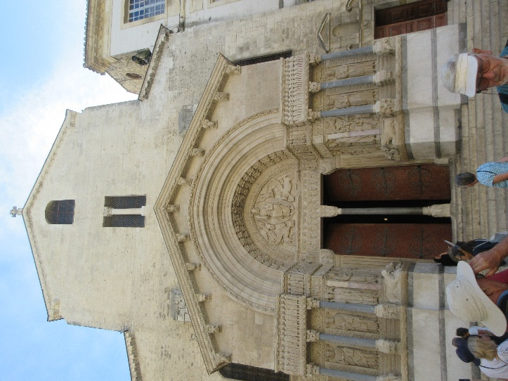
The tour was slated to end in front of the cathedral in the main town square, at our farthest point from the ship, but our guide promised to call us a pedicab for the return trip—10 euros flat fee for one or two people. She spent some time at the end explaining the imagery carved around the door and columns, then called our pedicab, only to find that they weren't running on Sunday! Drat. She therefore accompanied us back partway, to a point where we were sure of the rest of the route. Near the ship, the other lady peeled off to visit the Monoprix department store. She had bought so much stuff on the trip that she needed to buy another suitcase!

Our next excursion, by bus, was less than an hour away, so she planned simply to wait, with her new suitcase, at street level and to take the suitcase with us on the bus, rather than having to shlep it all the way through the obstacle course to her cabin, then back through it to again to catch the bus.

At 11 am, we all trooped back up to street level and down the road past the lions to board the buses. David thought I was exaggerating until he saw all those stairs and ramps himself.

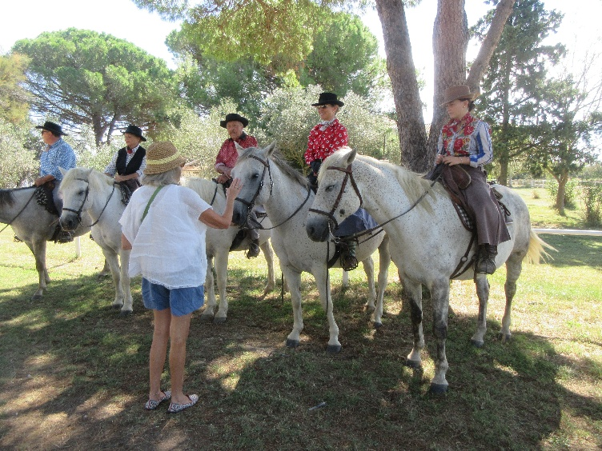
The delta of the Rhône is wide and marshy and forms a huge wetland known as the Camargue. it's famous for its production of salt, its rice production, its flamingos, its small white horses, and its big black bulls. David and I had driven through it, seen the salt pans and the flamingos, but had only distant and fleeting sights of the horses and bulls. But this time, we were driven to an actual working ranch for lunch and a close-up visit. Here's the family, assembled to greet us—left to right, our host, his mother, his father, his wife, and a young female ranchhand. The host's horse is only four years old and is therefore still grayish (like the Lipizzaners, the horses are born dark and whiten as they reach adulthood), the next two are purebred and white, and the last two have some non-Camargue blood and are speckled.

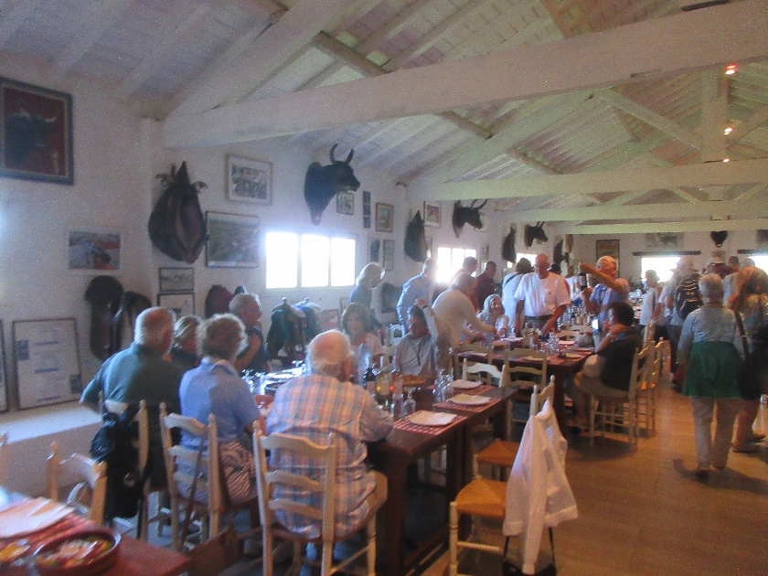
Lunch was three kinds of salad, followed by beef stew and the famous Camargue red rice. We were assured that all the heads on the walls were of bulls from this ranch that had died of old age (and been buried) in honorable retirement from the bull-ring. Only champion bulls made the cut to be displayed here.

Along the walls, below the heads, was the host's collection of saddles.

After lunch, we piled onto wagons fitted with benches and were driven out into the fields. Grandpa drove the tractor that pulled the wagons, and the others accompanied us on horseback.

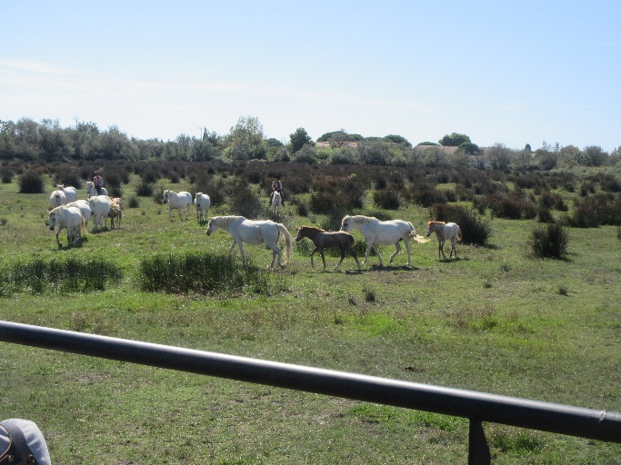
We first visited the horse fields—the horses live outdoors 24/7/365. They choose their own mates, and mares give birth outdoors without assistance. But the morning after a foal is born, people are out there petting it, breathing into its nostrils, and otherwise ensuring that it will be comfortable around humans.

When it grows up and is broken to saddle, it will be assigned to a single rider for life. For the sort of work they do—principally herding and cutting—trust and cooperation between horse and rider are essential; they have to know each other well.
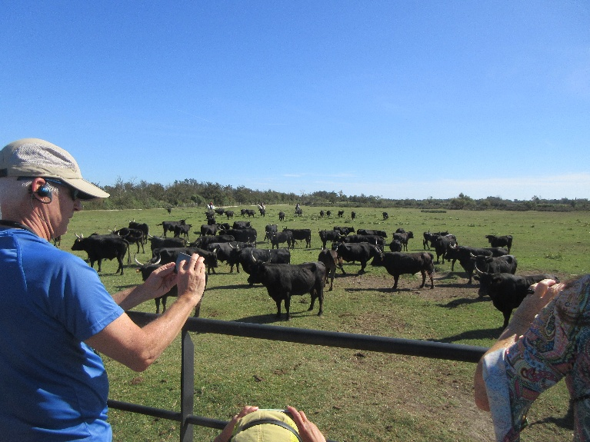
Then we visited the bull fields. Most cattle ranching involves producing either beef or milk, but here, the product is bulls for the ring. These are not Spanish bulls, with forward-pointing horns, killed in the ring. Camargue bulls have upward-pointing horns (they're supposedly the most direct descendents of the aurochs). Some are eaten, but the best go to the ring. In Camargue-style bullfighting, bulls (and not matadors) are the stars. People come to the stadium not to see and follow the careers of big-name matadors but to see and follow the careers of big-name bulls. The bull is turned loose in the ring with 10 athletic young men (I believe the technical term is "lunatics") who vie with each other in attempting to capture a small red ribbon on the bull's forehead, tied between the horns. Each is armed only with a set of rounded hooks, which they wear like brass knuckles, with the hooks protruding between their fingers, intended for snagging the red ribbon. The bull (if he's a good one) takes exception to some crazy guy jumping around in front of him and grabbing at his face and attempts to kill him. The guy, whether he gets the ribbon or not, then runs for his life and vaults the wooden wall surrounding the ring, and sometimes the taller one behind, while the bull does his best to gore him and sometimes even follows him over the wall. When the bull is then distracted by some other guy, the first one can reenter the ring. Way more fun to watch than the Spanish style.

The ranch we visited, Les Marquises, has produced many champion bulls—those that excel at defending their red ribbons—including one particularly legendary champion, Goya. Goya died of old age 1986, but people still come to the ranch just to visit his grave. (We drove by it on the way back.) Apparently, nobody took Goya's ribbon.

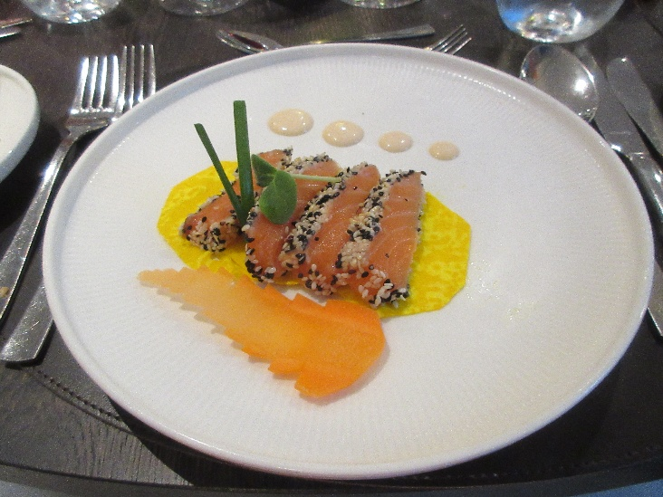
We got back to the ship with time to wash up and change before the captain's fairwell reception, followed by the fairwell dinner.

The salmon tataki starter was particuarly photogenic (and delicious)!

Dessert was baked Alaska, which was trooped through the dining room with great ceremony and many sparklers. I usually think of baked Alaska as spectacular looking but pretty blah as a dessert. This one, though, was terrific! Three flavors of freshly made ice cream fully encased in cake and coated with meringue that was more like marshmallow and heavily flavored in its own right. Then berry compote ladled over the top!
